NAVARRO, ROD GERYK C.

2021106441 CPE160P-4_A1

**Intelligent waste management system using deep learning with IoT**

**Objectives:**

The aim of the paper is to create an IoT based technology to simulate a waste management system for the demolition of waste conducted by recycling and landfilling. This paper proposed the use of ultrasonic sensor, weight sensor, and a microcontroller to build the waste management system. The waste management system's capable architecture, based on deep learning and IoT, is reflected in this study.

**Materials:**

* Microcontroller
* Ultrasonic sensor
* Weight sensor

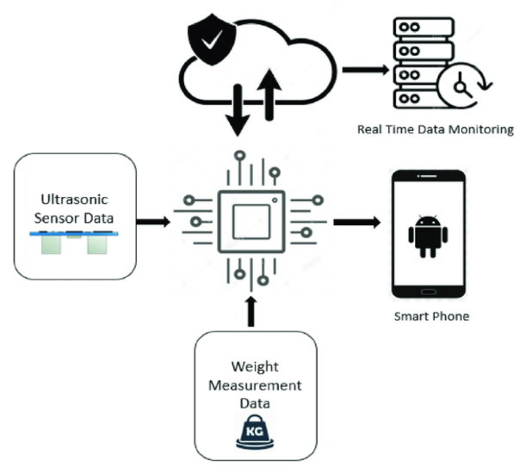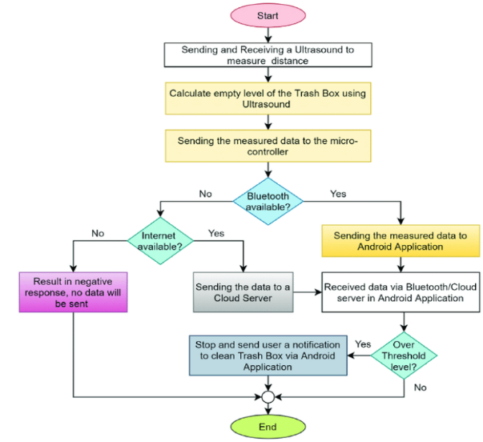**Hardware components: Flowchart:**

**Functionalities:**

Using a microcontroller equipped with several sensors, the concept presents the architectural design of a smart garbage can. For data monitoring, the suggested approach makes use of Bluetooth and IoT connectedness. Bluetooth facilitates close-quarters data monitoring via an Android app, while IoT allows for real-time data administration from anyplace.

**Why it is considered an application of transducers and sensors?**

The intelligent waste management system uses transducers and sensors to monitor waste levels. The ultrasonic and weight sensors convert physical measurements like distance and mass into electrical signals processed by a microcontroller. This data is then transmitted via IoT for real-time monitoring and management.

**Reference:**

Rahman, Wahidur & Islam, Rahabul & Hasan, Arafat & Bithi, Nasima & Hasan, Mohammad & Rahman, Mohammad Motiur. (2020). Intelligent waste management system using deep learning with IoT. Journal of King Saud University - Computer and Information Sciences. <https://www.researchgate.net/publication/344385811_Intelligent_waste_management_system_using_deep_learning_with_IoT#pf4>

NAVARRO, ROD GERYK C.

2021106441 CPE160P-4_A1

**Low-cost bus seating information technology system**

**Objectives:**

The study's goal is to create, put into practice, and evaluate an Internet of Things-based system for monitoring bus occupancy in real-time. Using a variety of sensors, such as the IR sensor and force-resistive resistors, among others, it seeks to offer precise data on passenger entry, seat occupancy, and bus location.

**Materials:**

* Raspberry Pi microcontroller
* IR sensor
* Force-sensitive resistors
* GPS
* USB camera

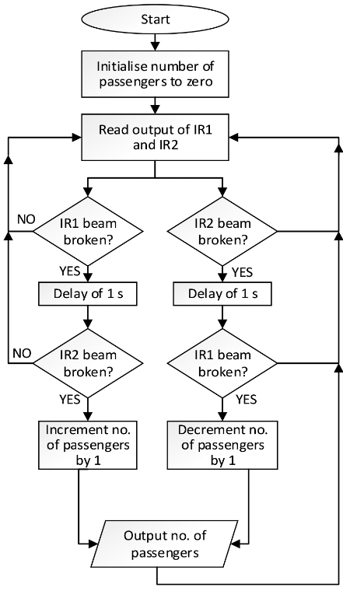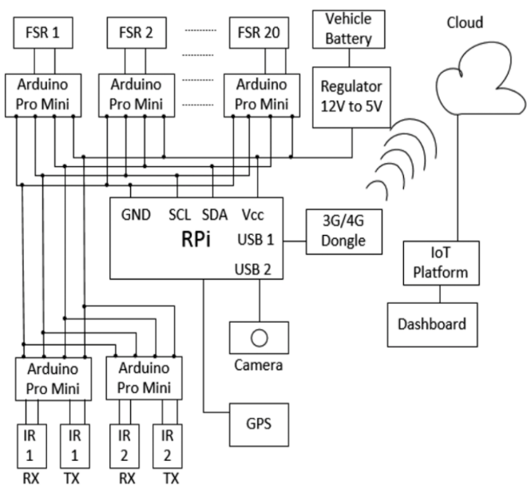**Hardware components: Flowchart:**

**Functionalities:**

The Bus Seating Information Technology system uses Internet of Things to track vehicle position and occupancy in real time. Utilizing a Raspberry Pi for data processing, it uses sensors to identify seat occupancy, passenger movement, and GPS tracking. An IoT platform receives the gathered data, which can then be viewed via a desktop or mobile app.

**Why it is considered an application of transducers and sensors?**

Since the bus seating information system utilizes force-sensitive resistors and infrared sensors to detect seat occupancy and passenger movement, it is an example of a transducer and sensor application. These sensors use a Raspberry Pi microcontroller to process electrical impulses that represent physical actions. The information is then sent over IoT to enable real-time bus occupancy and position tracking.

**Reference:**

Murdan, Anshu & Bucktowar, Vicky & Oree, Vishwamitra & Enoch, Marcus. (2020). Low-cost bus seating information technology system. IET Intelligent Transport Systems. 14. 1303-1310. 10.1049/iet-its.2019.0529. <https://www.researchgate.net/publication/346057714_Low-cost_bus_seating_information_technology_system>